TopCoder Direct VM Instances Management
Deployment Guide

Revision History
Author | Revision Number | Date
TCSASSEMBLER | 1.0 | 9/25/2013

Deployment Instructions 3
1. Organization of Submission 3
2. Application Setup 3
3. Ant .Properties File 3
4. Build Scripts Setup 3
5. Database Setup 3
6. Deployment Instructions 3
6.1. Fix missing root CA to access AWS (Optional if you are not in the VM) 3
6.2. Deploy direct application 4
7. Before the testing 4
8. Verification 4

Deployment Instructions

Organization of Submission
docs
Contains DeploymentGuide.doc - this file
direct
Contains all changed file for direct trunk in this assembly. The change is based on revision:
cloud_vm_service : 235054
direct: 235054
database: 83885
test_files
Contains the init.sql file and G5.pem for VM related table setup for testing.

Application Setup
The direct application is expected to be deployed to the following environment:

JDK 1.5
JBoss 4.2.3.GA
Informix DS 11.0

Ant .Properties File

No update for this contest, just follow the existing one in VM.

Build Scripts Setup
The ant command following will be used to deploy direct application.
1. deploy to deploy the application to jboss server.
2. deploy-apache-static to deploy all the static files to apache server.

Database Setup
- Login to VM as “direct” user.
- switch to “informix” user:
su - informix
Use “1nf0rm1x” (quotes for clarity) password.
- cd ~/scripts/
- svn up -r 83885
- ant reinstall_db
- Upload "init.sql" file from “test_files” folder of submission to the /tmp/ folder on VM.
- Execute update SQL:
cat /tmp/init.sql | dbaccess
- Switch back to “direct” user:
exit

Deployment Instructions

Fix missing root CA to access AWS (Optional if you are not in the VM)

The VM’s CA store is missing the root CA of AWS service. The root CA need to be installed to the VM before you can accessing AWS services on the VM.

Steps to install root CA:
1. Copy the G5.pem from “test_files” folder to the /tmp/ folder on VM
2. jbb
3. cp TC.cloud.ldap.keystore mykeystore
4. keytool -import -trustcacerts -alias extra-verisigntrustnetworkverisignclass3publicprimarycag5 -file /tmp/G5.pem -keystore mykeystore
When asked password, input: topcoder
When asked whether to add the cert to trusted cert store, enter: yes
5. vi run.conf
6. replace JAVA_OPTS="$JAVA_OPTS -Djavax.net.ssl.trustStore=TC.cloud.ldap.keystore" with JAVA_OPTS="$JAVA_OPTS -Djavax.net.ssl.trustStore=mykeystore"

Deploy direct application
Following steps will help you deploy the direct application.
- Login vm as ‘direct’ user
- Upload my submission to ~/temp_files, assuming the file name is submission.zip.
- jbb
- ./kill.sh (when "kill -9 jboss and backup logs?" asked, enter 'y')
- cd ~/direct
- svn up –r 235054
- cd cloud_vm_service
- svn up –r 235054
- cd ~/temp_files
- unzip submission.zip
- cp -r submission/direct/* ~/direct/
- cd ~/direct
- ant -f cloud_vm_service/build.xml dist_tcs
- ant deploy
- ant deploy-apache-static
- jbb
- ./start.sh
- use 'tn' command to see the jboss is properly started.

Before the testing

Please add your vm ip to your hosts file. And point it to cockpit.cloud.topcoder.com

Verification
  - Visit Home Page https://cockpit.cloud.topcoder.com/direct/,

  - Login with heffan/password, the page will be redirect to Enterprise Dashboards

  - Click the NEW PROJECT button to create a project.
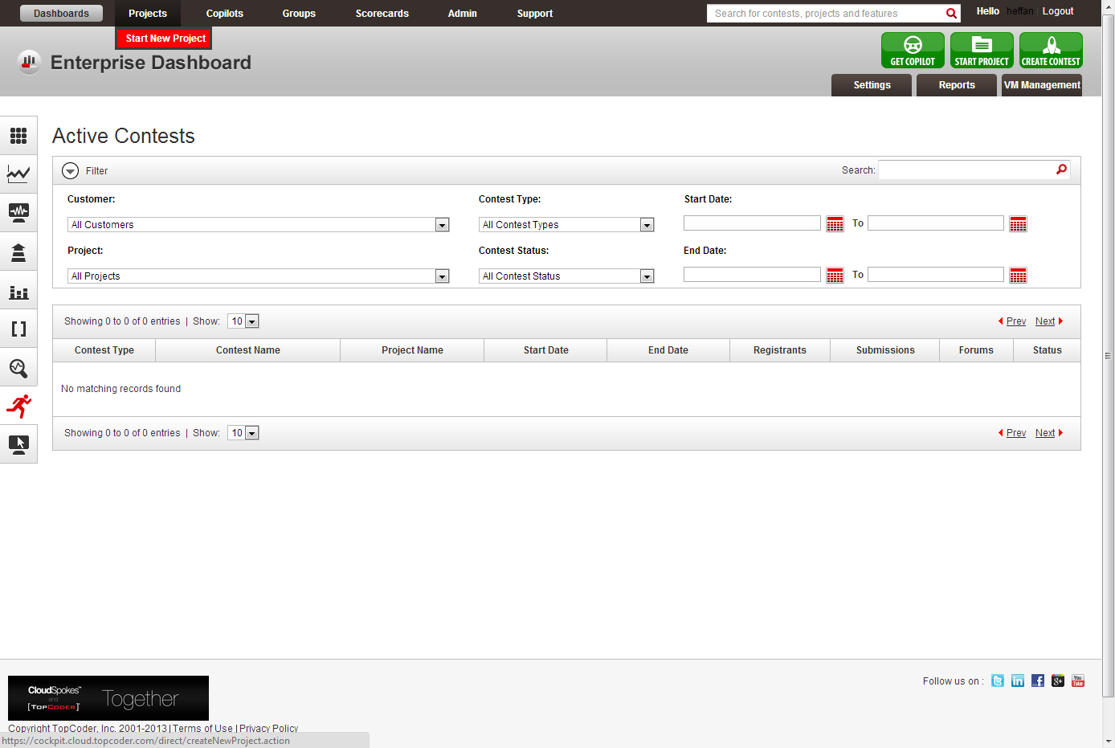

  - Create a Project named: “Project 1”
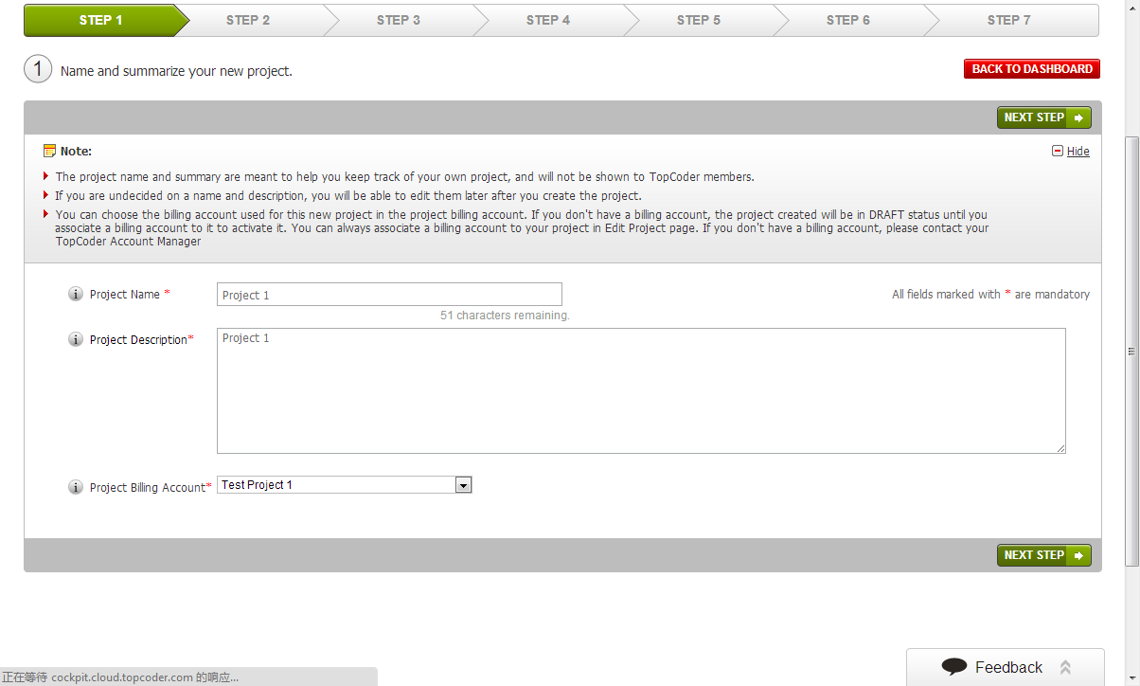
  - Choose Mobile Project Type, web app, then use default settings.
  - For hardware support, choose Unsure for all options.
  - Confirm and Launch the project.
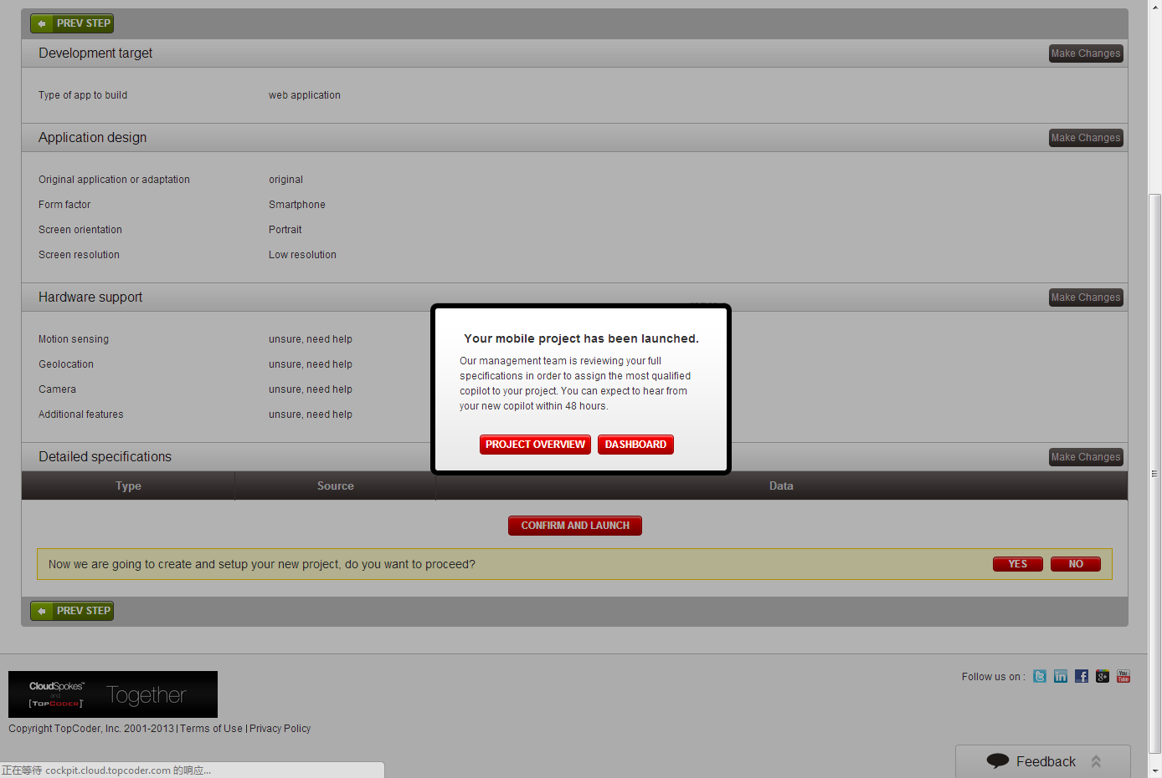
  - Go to project overview. Then go to the milestone tab.
  - Create a single milestone for the project: M1
  - Create two simple Contests in the created Project: “Contest 1” and “Contest 2”, choose “software assembly” as contest type, assign them to Milestone “M1”, billing account “Test Project 1”, select any Technology and use default value for other fields.

  - Create some VMs in the general VM management page

    - Go to VM Management page: https://cockpit.cloud.topcoder.com/direct/dashboardVMAction.action

    - Choose “Working_Image” as VM Image

    - Input the Id of the Contest just created

    - Set trunk as SVN Branch

    - Set user or twight or sandking as the TopCoder handle

    - Submit the request

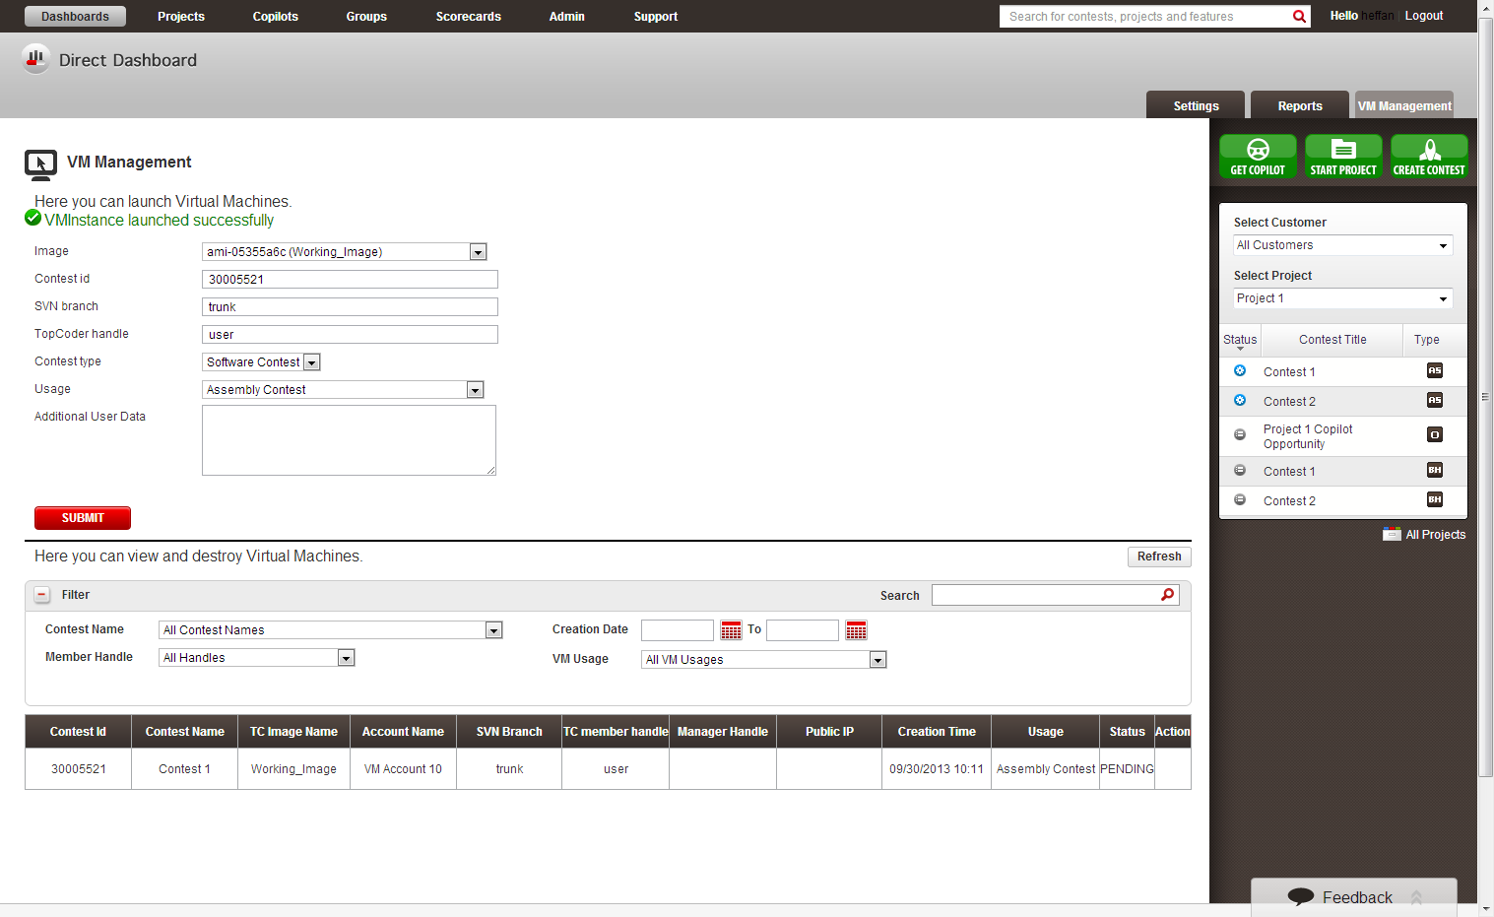

    - Repeat the above operation until you create 12 VMs (for pagination verification)

  - Terminate some of them.

  - Go to the project overview page, you can see there is a “VM Management” tab created.

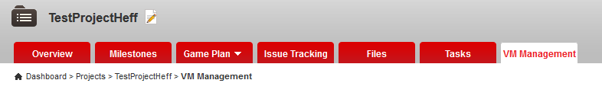

  - Go to the VM Management tab.

  - You can see VM for the project listed. You can see the Summary is there.
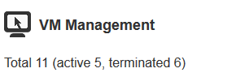

  - Verify the Filtering

    - By default only RUNNING instances are shown
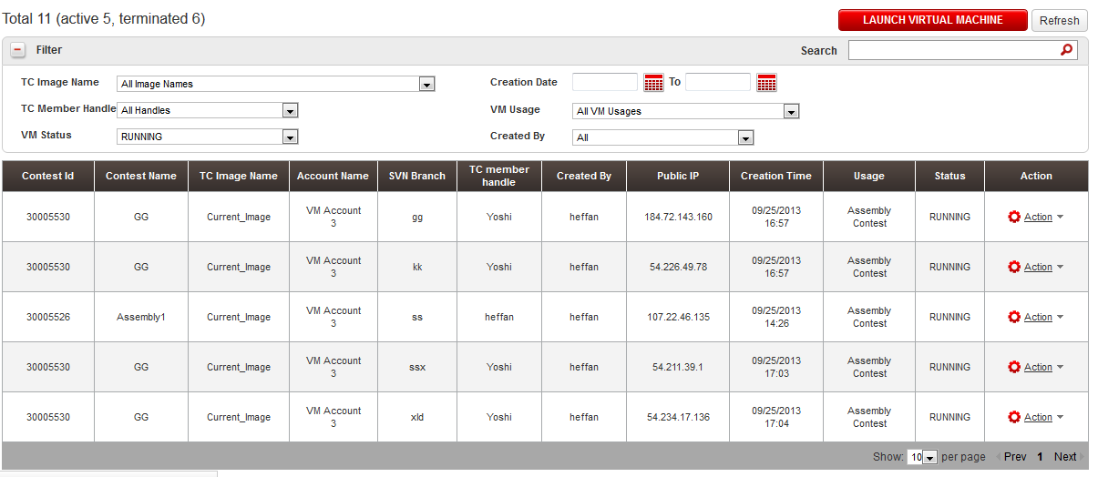

    - Change some of the parameters, you can see the result of filtering

  - Verify the Searching. Type several words in the searching box, you can see the result. For example search Yoshi, the result will only contain VMs assigned to Yoshi.
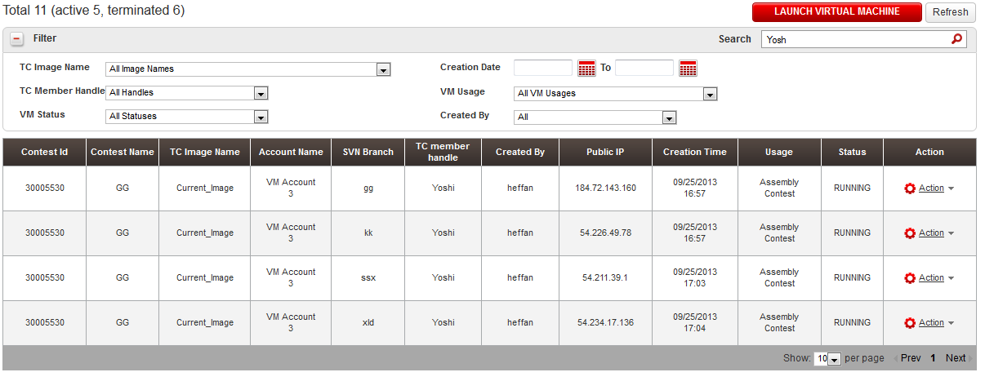

  - Verify Sorting. You can click on the table’s header. You can see the table can be sorted.

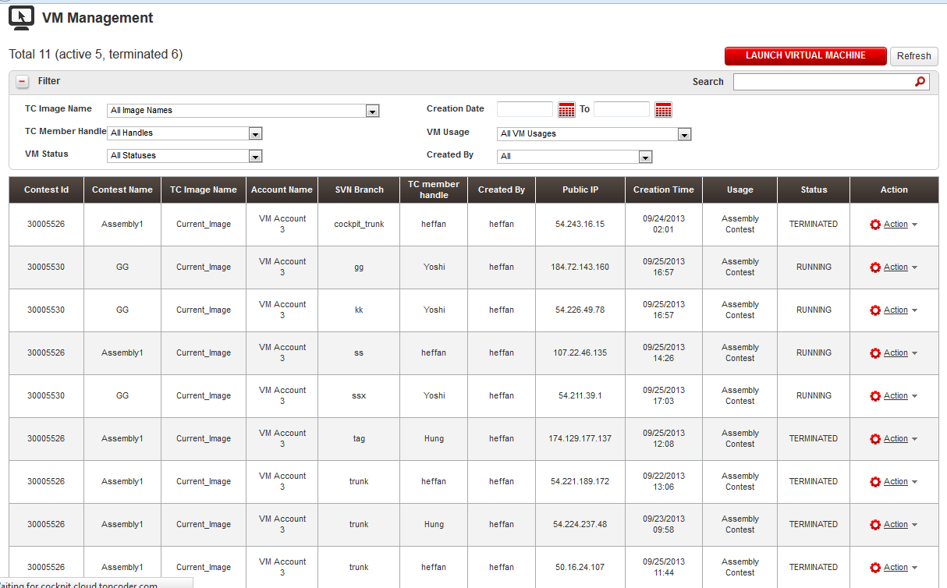

  - Verify Paging. Create enough VMs, then you can see that paging is working.

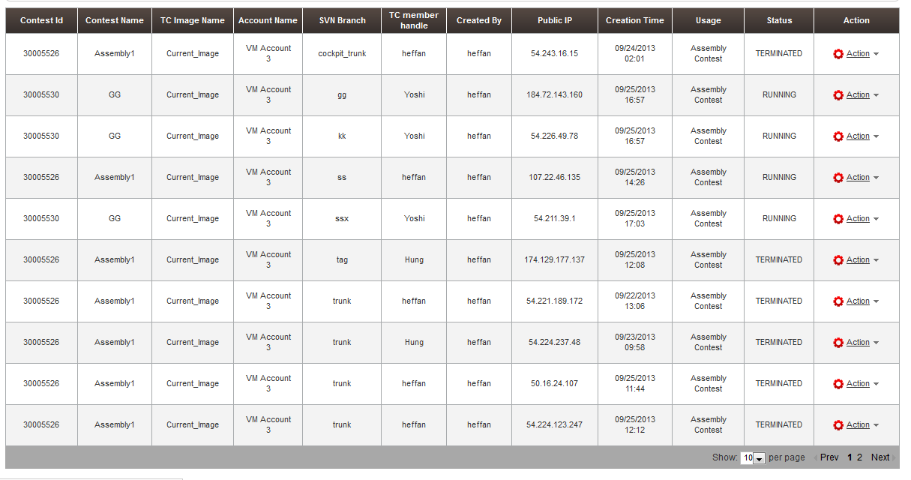

  - Action list
    - When you move the mouse above the Action link, a Drop down list will show up.
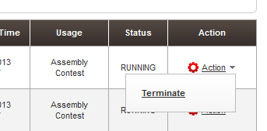
    - Currently there is only a Terminate action.
    - Only running VMs has Terminate enabled. All others are disabled.
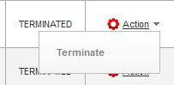
  - Verify permissions.

    - We have the following users:
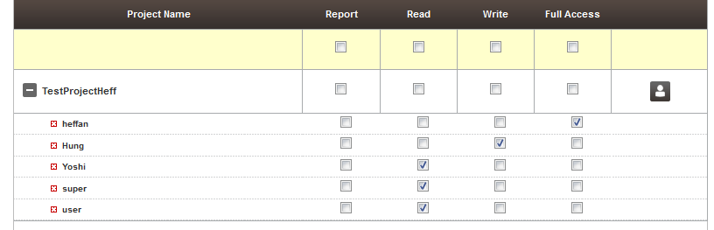
- super is also ADMIN
    - You can verify that heffan has full permission he can Terminate servers

    - Hung has write access, so he also can Terminate servers
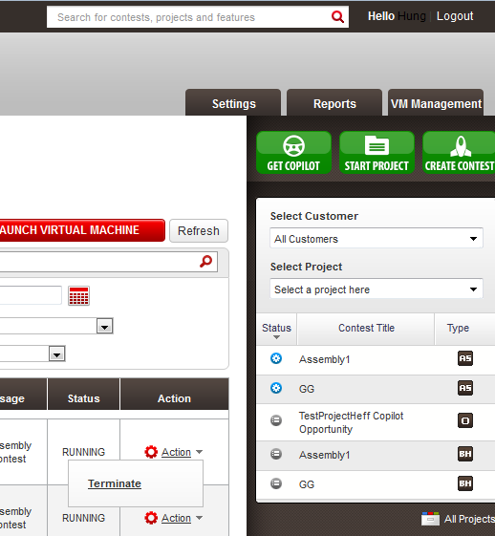
    - Yoshi is READ, but he is VM manager so he is also allowed to Terminate VMs
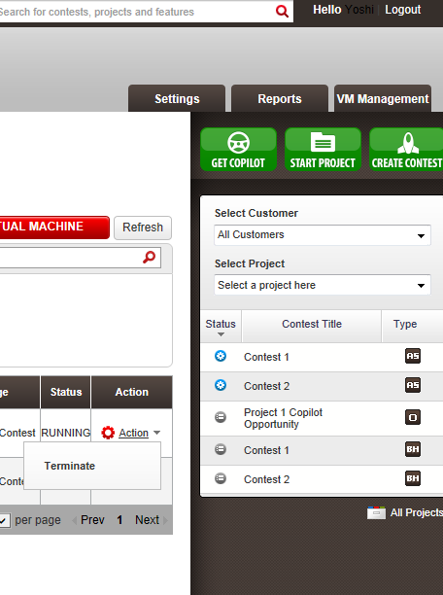
    - Super is administrator so he is also able to terminate the VM.
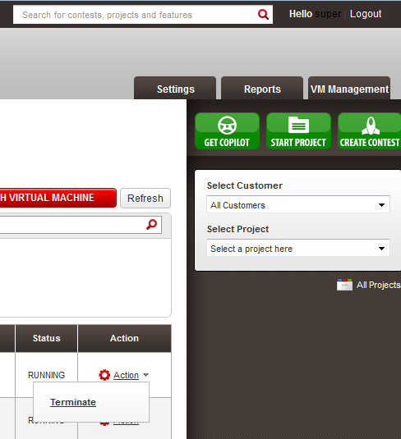

  - Refresh button will use AJAX to reload the table.
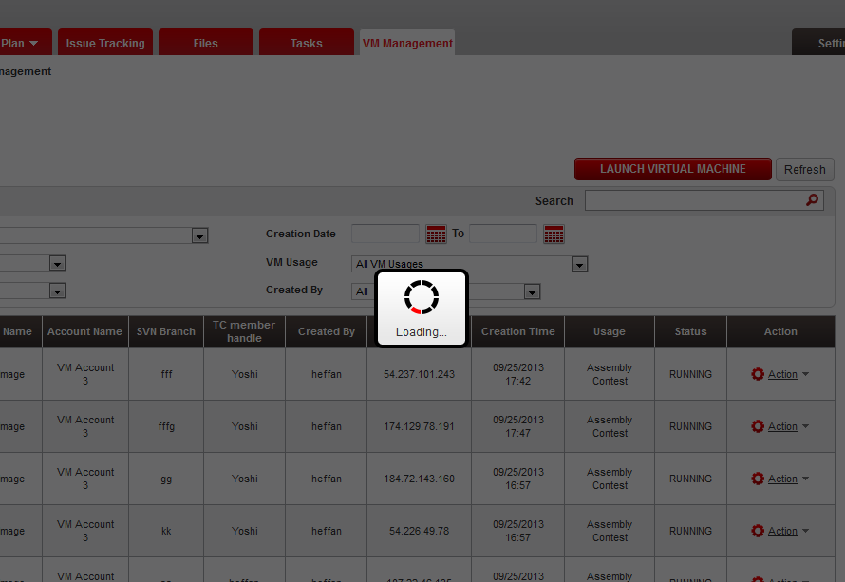
  - Bug fix 1: update the contest level VM instances table's action column to match the design of project one.
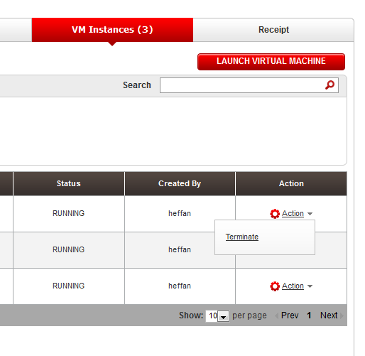
  - Bug fix 2: add the total active number of VM's on the name of the tab. You can see the number is there.
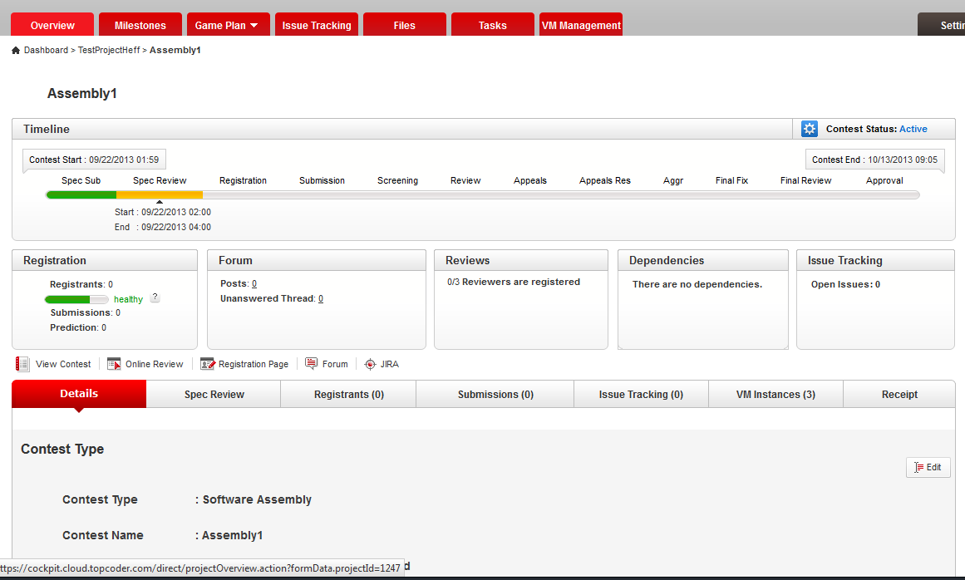
  - Bug fix 3: add a button called 'Launch Virtual Machine' above the filter
  - Bug fix 4: showing an error message in a popup with content.

    - Run update vm_instance set aws_instance_id = 'abc' where vm_instance_id = 6; to make a vm instance invalid.
    - In the contest level view. You can see it won’t block the page display now. A popup will show and VM stats will be 0.
The error message can be configured in the applicationContext.xml
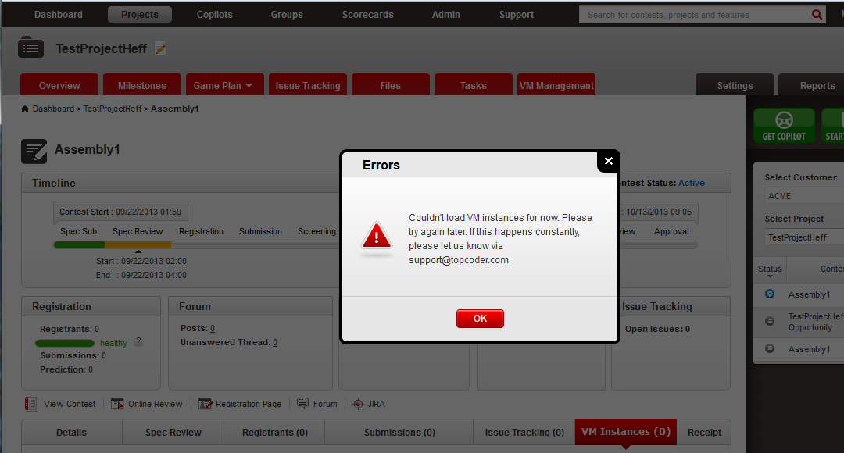
    - In the project level view. You can see it won’t block the page display. A popup will show and VM stats will be 0. Same as contest level one.
